COUNCIL ASSESSMENT REPORT

Panel Reference | 2019WCI025
DA Number | 308/2019/DA-CP
LGA | Campbelltown City Council
Proposed Development | Concept master plan for the redevelopment of the site as a mixed use development
Street Address | Lot X DP 409704, Lot 15 DP 14782, Lot 1 DP 1154928 Nos. 22 – 32 Queen Street, CAMPBELLTOWN
Applicant | Pacific Planning Pty Ltd
Owner | Campbelltown 88 Pty Ltd;  Supa 88 Pty Ltd
Date of DA lodgement | 04 February 2019
Number of Submissions | Nil
Recommendation | Consent, subject to conditions
Regional Development Criteria | Development with a capital investment value (CIV) over $30 million
List of all relevant s4.22 matters | - Environmental Planning and Assessment Act, 1979  - Environmental Planning and Assessment Regulations, 2000  - Greater Metropolitan Regional Environmental Plan No. 2 – Georges River Catchment  - Campbelltown Local Environmental Plan 2015 (CLEP).  - Campbelltown (Sustainable City) Development Control Plan 2015 (SCDCP).  - Water Management Act 2000.  - State Environmental Planning Policy (Infrastructure) 2007.  State Environmental Planning Policy (Building and Sustainability Index: BASIX).  - State Environmental Planning Policy No.65 (SEPP 65) - Design Quality of Residential Apartment Development.  - Apartment Design Guide (ADG).  - State Environmental Planning Policy 55 (SEPP 55) - Remediation of Land.  - State Environmental Planning Policy (Sydney Region Growth Centres) 2006
List all documents submitted with this report for the Panel’s consideration | Officer’s Assessment Report  Recommended Conditions of Consent  Building envelope, Massing envelope and Basement Plans
Report prepared by | Stephen McDiarmid – Senior Strategic Planner
Report date | 24 August 2020

Summary of s4.22 (Concept plan application) matters  Have all recommendations in relation to relevant s4.22 matters been summarised in the Executive Summary of the assessment report? | Yes
Legislative clauses requiring consent authority satisfaction  Have relevant clauses in all applicable environmental planning instruments where the consent authority must be satisfied about a particular matter been listed, and relevant recommendations summarised, in the Executive Summary of the assessment report? | Yes
Clause 4.6 Exceptions to development standards  If a written request for a contravention to a development standard (clause 4.6 of the LEP) has been received, has it been attached to the assessment report? | N/A
Special Infrastructure Contributions  Does the DA require Special Infrastructure Contributions conditions?  Note: Certain DAs in the 9Western Sydney Growth Areas Special Contributions Area may require specific Special Infrastructure Contributions (SIC) conditions | Yes
Conditions  Have draft conditions been provided to the applicant for comment?  Note: in order to reduce delays in determinations, the Panel prefer that draft conditions, notwithstanding Council’s recommendation, be provided to the applicant to enable any comments to be considered as part of the assessment report.  _________________________________________________________________ | Yes

Executive Summary

Council has received a Concept Development Application for the site that proposes five (5) tower forms over two (2) building platforms and a plaza of approximately 4,000sq.m. The proposed development is consistent with the current requirements of Campbelltown LEP 2015 (CLEP) and Campbelltown (Sustainable City) Development Control Plan 2015 (SCDCP) in addition to those specified in State Environmental Planning Policy No.65 (SEPP 65) - Design Quality of Residential Apartment Development and the associated Apartment Design Guide (ADG). The proposed mixed use buildings which form an integral part of this concept application do not exceed the site’s current height maximum limit of 26 metres.

This application has been assessed against the provisions of Section 4.22 (Concept Plan Applications) of the Environmental Planning and Assessment Act 1979. Upon completion, it was determined that the concept application met satisfactory compliance with these provisions. The proposal has also been found to satisfy the relevant State Environmental Planning Policies, including, clause 7 of State Environmental Planning Policy 55 (SEPP 55) – Remediation of Land. Council is satisfied that the site is suitable for the proposed development which also reflects compliance with the relevant provisions specified in Campbelltown Local Environmental Plan 2015, Campbelltown (Sustainable City) Development Control Plan 2015 and the Glenfield to Macarthur Urban Renewal Corridor

It is considered that the overall social and economic impacts of the proposed concept development will be positive, and that potential impacts on the natural and built environments can be mitigated through design measures and the imposition of specific conditions of consent.

All relevant clauses in the following environmental planning instruments have been satisfied and comprehensively addressed in the body of this assessment report.

The public exhibition and notification of this application to surrounding residents concluded on 21 March 2019. No submissions were received.

The site’s location and zoning reinforce that the proposed concept masterplan will be a suitable land use and is, therefore, considered to be in the broader interests of the general public.

Accordingly, it is recommended that this concept application be approved with appropriate conditions of consent.

The Site and Surrounding Land Uses

The site has a total area of 20,465.7m² and is located on Queen Street which is the main commercial thoroughfare into the Campbelltown Central Business District (CBD). The site is highly visible from a number of significant vantage points around Campbelltown and will form a significant western gateway into the city.

The site is currently zoned B4 Mixed Use and is surrounded on three sides by land with the same zoning, in addition to bordering a R4 ‘High Density Residential’ zone to the south.

The site fronts Queen Street to the west, Campbelltown Performing Arts High School to the south-east with low rise mixed use retail/commercial premises which adjoin the south-western boundary. An existing motor inn and garden centre are located on the northern adjoining sites which also contain a number of heritage listed two-storey sandstone bar and stable buildings which form part of the John Warby Estate.

The site is approximately 1.2km walking distance from Campbelltown railway station and adjoins the Campbelltown High School (at the rear) which includes large expansive areas of open space.

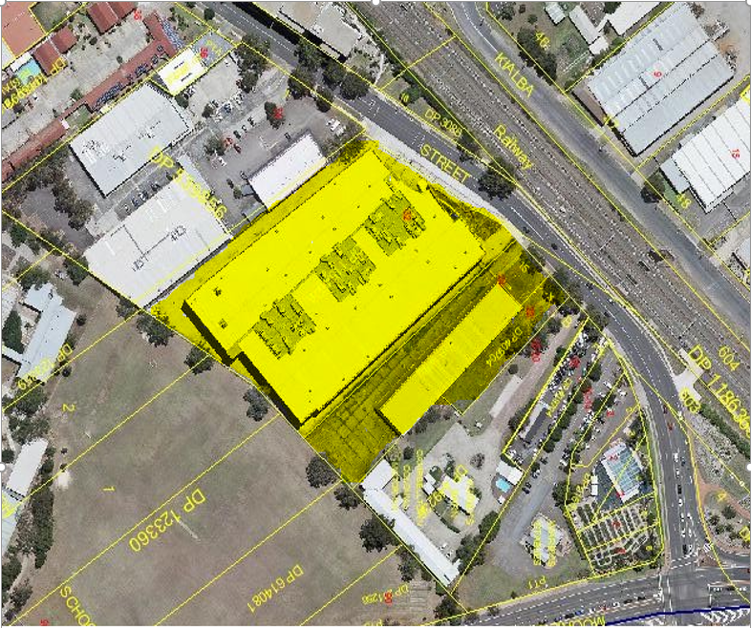
Aerial Site Photo

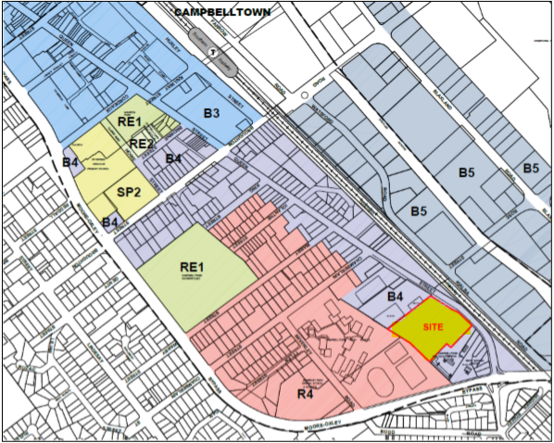
Locality and Zoning Map

Background and History

A development application (901/2016/DA-RA) was lodged for the subject site in April 2016.

The proposed development included the: -

- refurbishment and additions to an existing commercial building;
- construction of a mixed use commercial/residential development comprising 594 apartments within seven towers;
- provision of new ground level retail tenancies; and
- 1190 car parking spaces on-site.

The application was subsequently withdrawn following finalisation of the Campbelltown Precinct Plan in the Glenfield to Macarthur Urban Renewal Corridor Strategy and preparation of the draft Reimagining Campbelltown Strategy. These documents formed the basis of a new strategic planning framework for Campbelltown

On 22 June 2018, a planning proposal request was submitted to Council which sought an increase to the maximum permissible building height control for this site from 26 to 34 metres (8 storeys); 49.5 metres (13 storeys); 65 metres (18 storeys); 77 metres (22 storeys); and 87 metres (25 storeys) over six defined building envelopes.

On 4 September 2018, a presentation was made to Campbelltown City Council Councillors where the proposed controls and development concept were outlined. A consequence of these discussions resulted in a revised planning proposal request which amended the intended heights on site. A revised planning proposal request was submitted on 11 September 2018 which sought to increase the maximum building height on this site from 26 metres to 37 metres (10 storeys); 53 metres (15 storeys); 56 metres (16 storeys); 59 metres (17 storeys); and 62 metres (18 storeys).

On 28 November 2018, the Campbelltown Local Planning Panel considered the planning proposal and recommended, in part, that: -

“the applicant be invited to submit further information in the form of concept development application and site specific DCP….”.

In response to the Campbelltown Local Planning Panel’s advice a concept application was prepared that sought consent for the concept to which the planning proposal related and sought to deal with many aspects that the Panel raised. The Concept DA does not seek consent for any physical works and only seeks consent for massing and footprints that are consistent and compliant with the current provisions of the Campbelltown LEP 2015. The Concept DA was lodged on 5 February 2019.

In relation to the planning proposal, after careful consideration of the key matters relating to the site, Council staff prepared a draft planning proposal for the site which recommended lower building heights than requested by the applicant. The recommended planning proposal included:

• maintaining a building height of 26 metres (eight storeys) for the part of the site that is immediately adjacent to the heritage building

• increase the building height from 26 metres (eight storeys) to 32 metres (ten storeys), 38.5 metres (12 storeys) and 45 metres (15 storeys), across other buildings on site; and

• decrease the building height from 26 metres to 1.5 metres for the area proposed for ground floor plaza/open space.

On 11 June 2019, the elected Council endorsed these heights and the planning proposal was forwarded to the Department of Planning, Industry and Environment for a Gateway Determination in accordance with Section 3.34 of the Environmental Planning and Assessment Act 1979.

On 17 January 2020, a conditional Gateway determination was issued in support of the progression of the Planning Proposal. Condition 1 of the Gateway required that, prior to public exhibition, the planning proposal be updated. Condition 1(f) required that options be explored to increase the size of the proposed local open space and that amendments be introduced to the planning proposal if necessary.

The exploration into the provision of additional open space resulted in the removal of building C within the concept and creation of approximately 4,000sqm of public open space for the community in accordance with the Gateway condition. Further, the concept plans have been amended to incorporate a community facility/social infrastructure on part of the open space area. This is supported by an accessible rooftop area and a 5 metre increase to the ground floor Queen Street setback which has been designed to activate the public domain along this interface.

In accordance with condition 1(h) of the Gateway determination, site specific DCP controls have been prepared which will be concurrently exhibited with the planning proposal These site specific controls were considered by the Campbelltown Design Excellence Panel (DEP) on 27 March 2020. The Design Excellence Panel was satisfied that the DCP achieved the previously stated objectives and made a number of suggestions to ensure that it reflected the height and densities identified by the planning proposal.

In addition, the Concept DA was also updated to reflect the layout and massing (to comply with the existing ‘Height of Building’ control nominated in the Campbelltown LEP 2015) which was also endorsed by the DEP.

On 11 September 2020, the Concept DA was considered by the Sydney Western City Planning Panel who considered that the proposal required further clarification by amended pland plans and clarification of certain details of the proposal, particularly:

- A “clear set” of concept drawings which include the building dimensions (elevation and sectional drawings), building heights (including lift over-runs and rooftop open space or any roof structures) and basement setback dimensions;

- Clarifying the potential use/s of ‘Building C’ and include on the updated plans;

- Clarification as to whether the proposed ‘Civic Plaza’ area is this intended to be utilised as public open space, communal open space or attached to the use of ‘Building C’;

- Substantiate the public open space provisions, as outlined in Council’s assessment report which refers to 4,000sqm of “additional public space”; and

- Identify the location of pedestrian path network including resolving any inconsistency on the updated plans between the location of deep soil zones and the proposed eastern access road, noting that there is a need for additional landscaping along the common boundary with the adjoining school site.

Council requested the applicant to provide additional information to address these requirements. On 7 October 2020, the applicant provided responses to these requests which have been attached to this report for the Panel’s review and consideration. This report and the recommended consent conditions have been updated in response to this information.

This Concept DA, therefore, now supports the recommendations of the Campbelltown Local Planning Panel, the DEP and compliments the planning proposal process, which is discussed further in this report.

PROPOSAL

The application does not seek consent for any physical works to commence on site. This proposal has been submitted as a concept development application, pursuant to Section 4.22 of the Environmental Planning and Assessment Act 1979, which states: -

4.22 Concept development applications

(1) For the purposes of this Act, a concept development application is a development application that sets out concept proposals for the development of a site, and for which detailed proposals for the site or for separate parts of the site are to be the subject of a subsequent development application or applications.

(2) In the case of a staged development, the application may set out detailed proposals for the first stage of development.

(3) A development application is not to be treated as a concept development application unless the applicant requests it to be treated as a concept development application.
(4) If consent is granted on the determination of a concept development application, the consent does not authorise the carrying out of development on any part of the site concerned unless:

(a) consent is subsequently granted to carry out development on that part of the site following a further development application in respect of that part of the site, or

(b) the concept development application also provided the requisite details of the development on that part of the site and consent is granted for that first stage of development without the need for further consent.

The terms of a consent granted on the determination of a concept development application are to reflect the operation of this subsection.

(5) The consent authority, when considering under section 4.15 the likely impact of the development the subject of a concept development application, need only consider the likely impact of the concept proposals (and any first stage of development included in the application) and does not need to consider the likely impact of the carrying out of development that may be the subject of subsequent development applications.

The submitted concept plans form the “concept proposal” for the development and do not seek approval to commence any physical works on site. Approval to construct the proposed mixed use development, in accordance with the submitted Concept Plans, will be subject of subsequent development applications.

This Concept Development Application seeks approval for a master plan which includes: -

- concept building footprints and massing envelopes for the future development of the site across two (2) key buildings and five (5) tower forms with a maximum height of 26 metres;
- conceptual identification including location of public open space and communal gardens;
- Vehicular access arrangements and egress points to/from the proposed basement car park; and
- Location and network of pedestrian paths.

In accordance with Section 4.22 of the EP&A Act 1979, following determination of this Concept DA, further detailed design work will be undertaken and subsequent detailed staged applications submitted for separate parts of the site.

Specifically, this concept application seeks approval for the submitted building footprints, building massing, setbacks, basement location and location of open space areas which reflect compliance with the existing CLEP provisions, including a maximum building height of 26m. As this application does not seek consent for physical works, the demolition and construction work associated with redeveloping this site will be the subject of subsequent Development Applications that must be consistent with this concept in accordance with section 4.22 of the Act.

It is expected that the first application to be determined after the approval of this concept application would be an application for the demolition of the substantial existing structures located on the land.
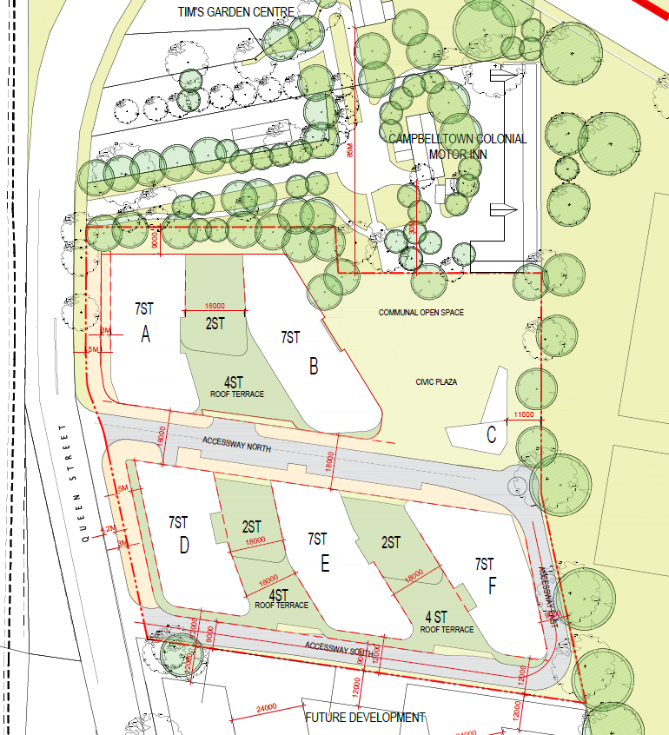

Concept Site Plan

Assessment Report

The development has been assessed in accordance with the heads of consideration under Section 4.15 of the Environmental Planning and Assessment Act, 1979, and having regard to those matters, the following issues have been identified for further consideration.

1. Planning Provisions

1.1 Threatened Species Conservation Act 1995 (TSC Act)

Section 1.3(e) of the EP&A Act requires consideration as to whether a proposed development will have a significant effect on threatened species, populations or ecological communities or their habitats. The DFO site is not classified as ‘Biodiversity’ Certified under the TSC Act. Notwithstanding this, no significant vegetation is proposed to be removed as part of this application.

1.2 Integrated Development/External Referrals

1.3 National Parks & Wildlife Act 1974

The subject land is not archaeologically sensitive and there are no such constraints to it being developed. Therefore, no integrated development approval was required under the National Parks and Wildlife Act 1974. A recommended condition of consent requires the preparation of an unexpected finds protocol for the site.

1.4 Heritage Act 1977

The subject development site adjoins a state significant heritage item known as the “Warby Barn and Stables” site which consists of two sandstone agricultural buildings that once formed part of the larger John Warby Estate.

This site is listed on the State Heritage Register as Item No. I00497 and is of considerable significance to the history of Campbelltown.

The applicant has submitted a Heritage Study, prepared by Lucas, Stapleton and Johnson, which provided the following guiding principles in terms of protecting this item while developing the adjoining DFO site:

- provision of an appropriate backdrop to the Warby site as seen from the north-east (Campbelltown Road overpass) with the old Campbelltown presented against the "new Campbelltown" without overwhelming the historic site; and

- ensure the project does not prejudice the future development of the Warby site, rather provide opportunities for the future development of the Warby site in a way that will enhance its significance and interlink with the Project site.

The revised concept removed ‘Building C’ and ensures that the immediate interface with the heritage buildings is not built upon, creating a sensitive landscaped interface with strong connections and links between the development site and the heritage. It must also be noted that the development concept has sought to replicate the old access and movement arrangements associated with the Warby landholding.

While the Warby homestead has long been demolished, it previously existed in front of the barn building with an entry drive from Queen Street. The 1850’s Warby estate plan is included below along with a potential opportunity to replicate this historical connection as part of the proposal.

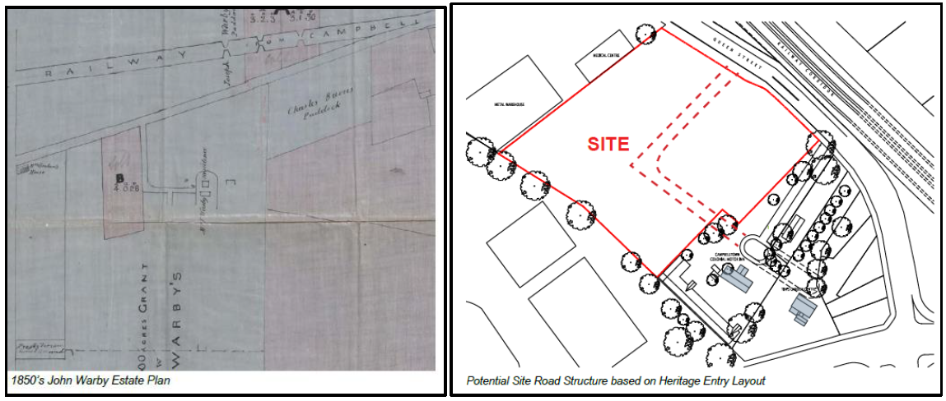

Further, the concept provides for a minimum 9 metre ground floor setback for the northern part of the site. The applicants’ vision for the built form interface is to integrate the setback into the development proposal rather than providing a landscaped buffer zone which tends to result in visual screening and a separation between the two sites. The setback allows for a softening of the property boundary, with scattered tree plantings, allowing views into and through the Warby site which also enhances the landscape character of this precinct.

The process adopted in this application to confirm the building envelopes and massing prior to submitting any development application for works adjacent to the heritage buildings and their curtilage ensures the consideration on the impact of the heritage items occurs as early as possible in the process. Any subsequent development application for physical works will need to be consistent with this concept plan to ensure that the heritage significance of these buildings is protected from being adversely impacted. The relationship of the location of the building footprints, setbacks, and quantum and location of the open space appears to be supported from a heritage perspective.

1.5 State Environmental Planning Policy (Infrastructure) 2007

Various provisions within the Infrastructure SEPP are applicable to the application. These are discussed below:

Subdivision 2 – Clause 45 – Development likely to affect an electricity transmission or distribution network – determination of development applications

This clause requires the consent authority to notify the electricity supply authority and consider any response received, for any of the following works:

- the penetration of ground within 2m of an underground electricity power line or an electricity distribution pole or within 10m of any part of an electricity tower,
- development carried out:

(i) within or immediately adjacent to an easement for electricity purposes (whether or not the electricity infrastructure exists), or
(ii) immediately adjacent to an electricity substation, or
(iii) within 5m of an exposed overhead electricity power line,

- installation of a swimming pool any part of which is:

- within 30m of a structure supporting an overhead electricity transmission line, measured horizontally from the top of the pool to the bottom of the structure at ground level, or
- within 5m of an overhead electricity power line, measured vertically upwards from the top of the pool,

(d) development involving or requiring the placement of power lines underground, unless an agreement with respect to the placement underground of power lines is in force between the electricity supply authority and the council for the land concerned.

The development shown in the concept master plan would involve works described by subclauses (a), (b) and (d) as an overhead power line traverses the site.

Comment: As this application does not seek consent for the physical works to construct the subject mixed-use proposal, a condition will be imposed in any future development consents requesting details on how the existing power lines will be relocated underground, in accordance with the specific requirements of this SEPP.

Clauses 85 and 86 – Development and excavation adjacent to rail corridors

This clause requires the consent authority to notify the rail authority and consider any response received, for any of the following works:

Development that:

(a) is likely to have an adverse effect on rail safety, or
(b) involves the placing of a metal finish on a structure and the rail corridor concerned is used by electric trains, or
(c) involves the use of a crane in air space above any rail corridor.

The concept master plan may potentially involve works that require the use of a crane in air space above a rail corridor, as described by subclause (c).

Comment: As this concept development application does not seek consent to construct physical works on site, a condition will be imposed in any future development consents requesting details about the height and size of the proposed crane that will be used during construction. Details of this application were referred to Sydney trains for concurrence, in accordance with the specific requirements of this SEPP, however, no response was received.

Clause 87 – Impact of Rail Noise or Vibration on Non-Rail Development

Clause 87 of the Infrastructure SEPP sets out provisions relating to the potential impact of rail noise or vibration on non-rail development, which apply to development for a residential use that is likely to be adversely affected by rail noise or vibration. The subject site is located opposite the railway line so the provisions of Clause 87 apply to any application proposing to construct this development. Clause 87(3) requires all development for a residential use that is likely to be impacted must ensure that the following LAeq levels are not exceeded:

a) In any bedroom in the building – 35dB(A) at any time between 10.00pm and 7.00am,
b) Anywhere else in the building (other than a garage, kitchen, bathroom or hallway) – 40dB(A) at any time.

Comment: It is recommended that a condition of consent be applied to require an acoustic report to be submitted which provides an assessment of the potential noise impacts from the adjoining railway line, having regard to the relevant Australian Standards and the associated ‘Development Near Rail Corridors and Busy Roads – Interim Guideline’. This assessment must conclude that the development is capable of meeting the relevant guidelines, subject to the adoption of minimum acoustic performance standards for building elements, including glass seals and doors.

An assessment of rail vibration will not be required as the nearest rail line to any future development is located more than 60 metres away.

Clause 104 – Traffic Generating Development

Clause 104 sets out provisions relating to traffic generating development, as defined within Schedule 3 of the Infrastructure SEPP. Development for the purpose of constructing residential accommodation to create 300 or more dwellings, which are proposed to be accessed from a public road, is defined as ‘traffic generating development’.

As Section 3.5.3 (Access and Vehicular Movement) of the SEE proposes a basement car park which is anticipated to contain over 900 individual car spaces, any new applications seeking consent must be referred for concurrence. The concept application was referred to Transport for NSW who, in their response, indicated that further information is required in regards to the impact of the development, and this information is able to be adequately addressed through the placement of conditions on this consent. These conditions are incorporated into the recommended conditions of consent.

1.6 State Environmental Planning Policy (Building and Sustainability Index: BASIX)

As this concept development application does not seek consent for the physical works to construct the subject mixed use proposal, a condition is recommended requiring the submission of BASIX certificates for future DA’s, in accordance with the specific requirements of this SEPP.

1.7 State Environmental Planning Policy 55 – Remediation of Land

Council’s records indicate that the subject site has historically been used for residential and commercial/retail purposes which potentially could have had a number of contaminating activities being conducted on the site. As such, Clause 7 of the SEPP is relevant to confirm if there is any contamination present on site.

A phase 1 assessment was submitted and identifies the potential presence of an underground fuel tank on the site. As this concept application does not seek consent to physically construct the proposed mixed use development, it is considered reasonable for the concept to be approved. Further investigation of the underground fuel tank will need to be undertaken at demolition stage when the entire site is more accessible. It is appropriate for further investigation to occur as part of subsequent applications which will need to detail the required remediation and detail the measures that will be employed to ensure that this site it is suitable for the final development.

It is recommended that a condition be imposed in the concept consent requiring that a ‘Site Audit Report/Statement’, prepared by a suitably consultant, be submitted for Council’s approval prior to the issue of any subsequent development consent for building works.

1.8 Greater Metropolitan Regional Environmental Plan No 2 – Georges River Catchment

Aims and objectives

(1) The general aims and objectives of this plan are as follows:
(a) to maintain and improve the water quality and river flows of the Georges River and its tributaries and ensure that development is managed in a manner that is in keeping with the national, State, regional and local significance of the Catchment,
(b) to protect and enhance the environmental quality of the Catchment for the benefit of all users through the management and use of the resources in the Catchment in an ecologically sustainable manner,
(c) to ensure consistency with local environmental plans and also in the delivery of the principles of ecologically sustainable development in the assessment of development within the Catchment where there is potential to impact adversely on groundwater and on the water quality and river flows within the Georges River or its tributaries,
(d) to establish a consistent and coordinated approach to environmental planning and assessment for land along the Georges River and its tributaries and to promote integrated catchment management policies and programs in the planning and management of the Catchment,
(e) (Repealed)
(f) to provide a mechanism that assists in achieving the water quality objectives and river flow objectives agreed under the Water Reform Package.
Comment: The completed development will require implementing adequate water quality measures for any subsequent development application. These measures must be designed to ensure that any polluted and/or contaminated water, which occurs as a result of developing these sites, does not enter the stormwater and/or river systems.

(2) The specific aims and objectives of this plan are as follows:

Environmental protection and water quality and river flows:

(a) to preserve and protect and to encourage the restoration or rehabilitation of regionally significant sensitive natural environments such as wetlands (including mangroves, saltmarsh and seagrass areas), bushland and open space corridors within the Catchment, by identifying environmentally sensitive areas and providing for appropriate land use planning and development controls,
(b) to preserve, enhance and protect the freshwater and estuarine ecosystems within the Catchment by providing appropriate development,
(c) to ensure that development achieves the environmental objectives for the Catchment.

Comment: The completed development will require implementing adequate water quality measures as part of any subsequent development application. These measures must be designed to ensure that any polluted and/or contaminated water, which occurs as a result of developing these sites, does not enter the stormwater and/or river systems.

Regional role and land use:

(a) to identify land uses in the Catchment which have the potential to impact adversely on the water quality and river flows in the Georges River and its tributaries and to provide appropriate planning controls aimed at reducing adverse impacts on the water quality and river flows,
(b) to conserve, manage and improve the aquatic environment within the Catchment which is a significant resource base for the aquaculture industry, by providing controls aimed at reducing pollution entering the Catchment’s watercourses,
(c) to protect the safety and wellbeing of the local and regional community in accordance with standards and processes aimed at improving the water quality and river flows in the Catchment to enable recreation,
(d) to aid in the improvement of the environmental quality of Botany Bay in conjunction with other regional planning instruments.

Comment: The completed development will require implementing adequate water quality measures for any subsequent development application. These measures must be designed to ensure that any polluted and/or contaminated water, which occurs as a result of developing these sites, does not enter the stormwater and/or river systems.

1.9 State Environmental Planning Policy (Sydney Region Growth Centres) 2006

The Sydney Region Growth Centres SEPP was amended on 6 December 2019 to include the Greater Macarthur Growth Area as a designated growth centre. The subject site is located within the boundaries of the Greater Macarthur Growth Area, and is therefore subject to the provisions of the SEPP. Clauses 16 and 17 of the SEPP are relevant to the application and are discussed below.

Clause 16 - Development applications in growth centres - matters for consideration until finalisation of precinct planning for land

Clause 16(1) of the SEPP states:

(1) Until provisions have been specified in a Precinct Plan or in clause 7A with respect to the development of the land, consent is not to be granted to the carrying out of development on land within a growth centre unless the consent authority has taken into consideration the following—
(a) whether the proposed development will preclude the future urban and employment development land uses identified in the relevant growth centre structure plan,
(b) whether the extent of the investment in, and the operational and economic life of, the proposed development will result in the effective alienation of the land from those future land uses,
(c) whether the proposed development will result in further fragmentation of land holdings,
(d) whether the proposed development is incompatible with desired land uses in any draft environmental planning instrument that proposes to specify provisions in a Precinct Plan or in clause 7A,
(e) whether the proposed development is consistent with the precinct planning strategies and principles set out in any publicly exhibited document that is relevant to the development,
(f) whether the proposed development will hinder the orderly and co-ordinated provision of infrastructure that is planned for the growth centre,
(g) in the case of transitional land—whether (in addition) the proposed development will protect areas of aboriginal heritage, ecological diversity or biological diversity as well as protecting the scenic amenity of the land.

The SEPP does not include a precinct plan for the Greater Macarthur Growth Area, and therefore the above criteria requires consideration. In this regard, the following should be noted:

Comment: The Campbelltown Precinct Plan, released under the Glenfield to Macarthur Urban Renewal Corridor Strategy (Corridor Strategy), indicates that the subject site would be “Mixed Use Retail & Residential”. This implies that the existing B4 – Mixed Use zoning would continue to apply as “Residential flat buildings” are also deemed a permissible land use on these sites, in accordance with Campbelltown Local Environmental Plan 2015. Approval of the ‘Concept DA’ would not preclude any future urban land uses identified for the site under the Corridor Strategy so the proposed development is considered to be consistent with the relevant precinct planning strategy.

Therefore, the proposed development is considered to be satisfactory with regard to clause 16 of the SEPP.

Clause 17 - Referral to Department of Planning after release of precinct

This clause applies to land within a growth centres precinct that has been released by the Minister for urban development, and applies until provisions have been specified in a Precinct Plan or in clause 7A with respect to the development of the land.

The consent authority must, in the case of a development application for the carrying out of development (not being for a single residential dwelling) —

(a) with a capital investment value of more than $500,000, or
(b) in respect of land that has an area of more than 2 hectares, or
(c) that is a subdivision of land (being a subdivision that creates 2 or more lots),

refer the application to the Director-General of the Department of Planning for comment.

The consent authority must take any comments received from the Director-General of the Department of Planning, Infrastructure and Environment (DPIE) (within 21 days after the development application was referred to the Director-General for comment) into consideration when determining whether to grant consent to any such development.

Comment: At present, Council and the DPIE are working towards establishing new referral criteria pursuant to this clause, as the Department has acknowledged that the current referral criteria is inappropriate for the Greater Macarthur Growth Area. In this regard, it can be reasonably assumed that the DPIE has no current interest in this application. It is further noted that DPIE has supported the future development of this site in the manner proposed in this application, albeit with a different height, by issuing a positive gateway determination for the planning proposal to amend the maximum height of buildings map applying to the site.

1.10 Campbelltown Local Environmental Plan 2015 (CLEP)

The site is zoned B4 Mixed Use which nominates ‘residential flat buildings’ and ‘shop top housing’ as permissible land uses in this LEP. The submitted concept plan(s) will facilitate redeveloping this site as a mixed use proposal.

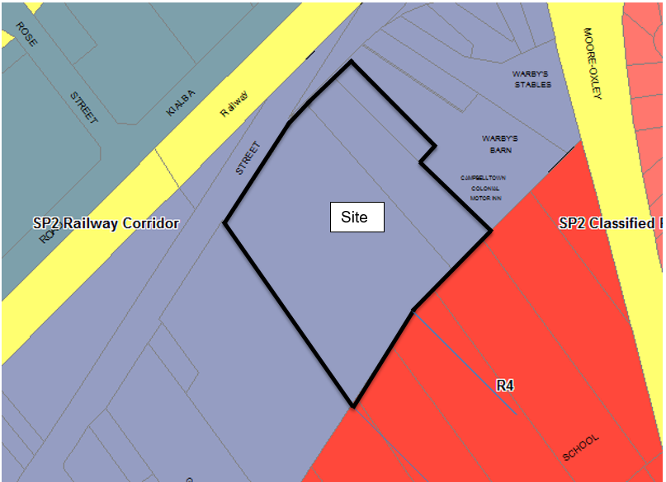

The objectives of the B4 zone are as follows:

- To provide a mixture of compatible land uses.
- To integrate suitable business, office, residential, retail and other development in accessible locations so as to maximise public transport patronage and encourage walking and cycling.
- To encourage the timely renewal and revitalisation of centres that are undergoing growth or change.
- To create vibrant, active and safe communities and economically sustainable employment centres.
- To provide a focal point for commercial investment, employment opportunities and centre-based living.
- To encourage the development of mixed-use buildings that accommodate a range of uses, including residential uses, and that have high residential amenity and active street frontages.
- To facilitate diverse and vibrant centres and neighbourhoods.
- To achieve an accessible, attractive and safe public domain.

The concept application is consistent with these objectives.

Clause 2.7 - Demolition requires development consent

A subsequent development application (1817/2020/DA-DEM) has been submitted seeking approval to undertake these works which will be the subject of a separate assessment by Council.

Clause 4.3 - Height of Buildings

All five (5) of the building towers, proposed in the concept masterplan, have a maximum building height of 26m which meets compliance with the CLEP 2015’s “Height of Building” map for these sites.

Clause 4.3A - Height restrictions for certain residential accommodation

No dwelling within any of the proposed residential flat buildings on site will be any higher than 2 storeys. This can be further assessed with each subsequent application.

Clause 7.3 - Design Excellence

(1) The objective of this clause is to ensure that development exhibits the highest standard of architectural and urban design as part of the built environment.

(2) This clause applies to development involving the construction of a new building or external alterations to an existing building on land in the following zones:

(a) Zone R3 Medium Density Residential,
(b) Zone R4 High Density Residential,
(c) Zone B2 Local Centre,
(d) Zone B3 Commercial Core,
(e) Zone B4 Mixed Use.

(3) Development consent must not be granted to development to which this clause applies unless the consent authority considers that the development exhibits design excellence.

(4) In considering whether development to which this clause applies exhibits design excellence, the consent authority must have regard to the following matters:

(a) whether a high standard of architectural design, materials and detailing appropriate to the building type and location will be achieved,
(b) whether the form and external appearance of the development will improve the quality and amenity of the public domain,
(c) whether the development detrimentally impacts on view corridors,
(d) how the development addresses the following matters:

(i) the suitability of the land for development,
(ii) existing and proposed uses,
(iii) heritage issues and streetscape constraints,
(iv) bulk, massing and modulation of buildings,
(v) street frontage heights,
(vi) environmental impacts such as sustainable design, overshadowing, wind and reflectivity,
(vii) the achievement of the principles of ecologically sustainable development,
(viii) pedestrian, cycle, vehicular and service access, circulation and requirements,
(ix) the impact on, and any proposed improvements to, the public domain,
(x) the interface with the public domain,
(xi) the quality and integration of landscape design.

Comment: Any subsequent development applications, seeking approval to construct the physical works on site, must demonstrate that the proposed building designs reflect satisfactory compliance with the all relevant requirements specified in this clause.

A draft site specific development control plan has been prepared which generally reflects the development proposed in this concept application with the exception that it refers to greater heights for the proposed residential towers as demonstrated in the associated planning proposal request for these sites.

The draft site specific development control plan was also referred to Council’s Design Excellence Panel (DEP) for advice which has now been incorporated into the draft DCP and, with the exception of the proposed heights, this concept application remains consistent with the draft site specific DCP.

The DEP were aware of this concept application and provided this advice on the basis that the proposed site layout and building envelopes were consistent with the site specific DCP in addition to considering that the concept masterplan proposal also demonstrated a significant degree of design excellence.

1.11 Campbelltown (Sustainable City) Development Control Plan 2015

Volume 1, Part 2 - Requirements Applying to All Types of Development

The general provisions of Part 2 of the Plan apply to all types of development.

Compliance with these relevant provisions of this Plan are discussed as follows:

Site Analysis - A detailed site analysis was submitted with this Concept DA and forms part of the intended master plan. While the concept proposal does not seek operational consent for the construction of any future mixed-use development, a Site Analysis was prepared as part of the Urban Design Concept which informed the proposed building envelope layout.

View and Vistas – The building heights proposed in this concept application meet compliance with the maximum 26 metre building height permitted on this B4 zoned site.

The building footprints, massing and location of the open space adjoining the state heritage listed Warby Barn and Stables seeks to protect the intimate and historic setting, while strengthening the relationship between the site and this important item.

Sustainable Building Design – It is recommended that a condition be imposed requiring that a ‘Sustainable Building Design’ report is submitted for Council’s approval with any subsequent development application for building works.

Landscaping - An integral component of the concept design is the ability of the project to potentially deliver a high standard of landscaping including approximately 4,000sqm of open space. The submitted Landscape Plan is contained in the attached “Urban Design Report” (Attachment 2) which includes the following as part of this concept:

▪ Large open (civic) open space areas and landscaped buffers between each of the proposed building envelopes and adjoining heritage item (Warby Barn and Stables) which includes extensive tree planting to screen the development and a pedestrian pathway.

▪ Rooftop gardens for the residential community.

On 7 October 2020, the applicant provided the following information in response to the Panel’s request on 11 September 2020 about the location of the pedestrian path network including a requirement to resolve any inconsistency on the updated plans, between the location of deep soil zones and the proposed eastern access road, while also noting that further landscaping would be required along the common boundary with the adjoining school site: -

“The pedestrian network and streetscape design is central to the future development outcome. The image below from the DCP identifies the locations of streetscapes and open spaces.

This complements the building footprints and elevations but is not submitted for consent, rather supports the masterplan and vision for the site. The concept plan identifies the building footprints. The roads and pedestrian pathways will require detailed work and design from a qualified engineer supported by the drainage design, and that will be subject to the application for development including roads and paths.

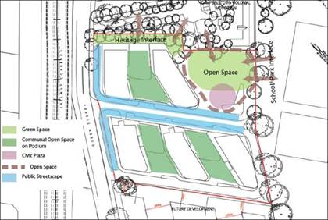

In relation to the east accessway, it is not proposed to provide a basement below this accessway. Therefore, while this is ‘deep soil’, no planting is proposed in the roadway. However, the concept plan has also been updated to illustrate the provision of a pedestrian link along the school ground boundary to the adjoining site which will allow for planting and landscaping supporting connectivity, anticipating future development and the growth of Campbelltown, and softening the edge to the adjoining site.”

It is considered that the applicant has not adequately addressed this matter in response the Panel’s request. Accordingly recommended condition 42 has been adjusted to include a requirement for the provision of a 3m wide deep soil planting area and landscaping between the sites boundaries, including the school’s boundary. These matters will therefore be further addressed in subsequent applications seeking consent for the physical building works on site.

Erosion and Sediment Control – As the concept development application does not seek consent to demolish, construct or excavate, this matter will be addressed in subsequent applications for demolition and construction.

Cut, Fill and Floor Levels – Sufficient information has been provided to satisfy the DCP requirements in regards to cut-and-fill.

Water Cycle Management - A comprehensive Water Cycle Management Plan will be prepared as part of a subsequent development application. This will incorporate and address principles of ‘Water Sensitive Urban Design’, including the efficient management of stormwater. A preliminary Water Cycle Management Report, dated December 2018, has been prepared for this concept application, by SGC Engineering, which ensures that future development can be adequately accommodated on the site

Heritage Conservation - The subject site does not fall within a ‘heritage conservation zone’ but does adjoin a property which contains the state heritage listed “Warby Barn and Stables”. A “Concept Plan Heritage Review”, prepared by Lucas Stapleton Johnson, was submitted with the application which considers the potential for negative impacts on the Warby Barn and Stables site as a result of the proposed mixed use development. The concept plan was informed by the Planning Proposal process and the submitted Heritage Impact Statement (dated 22 June 2018) made a number of recommendations for future development of this site.

The relationship of the concept to the adjoining heritage is considered in more detail under Section 2.3 of the proponent’s “Urban Design Report” which forms an attachment to this report.

Retaining Walls - This concept development application does not seek consent for physical works.

Security - While the application is just a concept, it does seek to support ‘Safer by Design’ principles by encouraging passive surveillance and creating active frontages. The Queen Street frontage will be activated at street level in order to create ‘main street’ configuration when viewed from the public domain. The large civic open space area, adjacent to the adjoining heritage site, will also activate and facilitate natural surveillance of this area. Entry points and driveways will be assessed as part of subsequent applications however the locations identified in the concept plan as suitable having regards to the ‘Safer by Design’ principles.

Waste Management - A Waste Management Plan prepared by ‘Elephant’s Foot’ Pty Ltd was included as part of this application. Waste storage, management and collection have been addressed in this report, in accordance with the relevant requirements specified in SCDCP.

All waste management associated with the construction and demolition phases of this mixed use development will be addressed in subsequent applications.

Provision of Services -, The site has ready access to all essential services including water, sewer and electricity.

Volume 1 Part 5 – Residential Flat Buildings and Mixed Use Developments

As this application is only seeking ‘concept’ approval, insufficient information was submitted to enable a full assessment of the relevant provisions specified in Volume 1, Part 5 (Residential Flat Buildings and Mixed-Use Development) of the SCDCP.

As a result, the following conditions have been recommended in the draft conditions of development consent: -

- Further Development Applications Seeking Operational Consent

Subsequent development applications must be prepared and submitted in accordance with Schedule 1 (Forms), Parts 1 & 2 (Information to be included in development application) of the Environmental Planning and Assessment Act, 1979.

Any such application must, where relevant, also be accompanied by information in accordance with Part 2(5)(Documents to accompany development application), for any defined “mixed use” and/or “residential flat building” development proposed in accordance with State Environmental Planning Policy No 65—Design Quality of Residential Apartment Development (SEPP 65), which includes: -

(a) an explanation of how—
(i) the design quality principles are addressed in the development, and
(ii) in terms of the Apartment Design Guide, the objectives of that guide have been achieved in the development,
(b) drawings of the proposed development in the context of surrounding development, including the streetscape,
(c) development compliance with building heights, building height planes, setbacks and building envelope controls (if applicable) marked on plans, sections and elevations,
(d) drawings of the proposed landscape area, including species selected and materials to be used, presented in the context of the proposed building or buildings, and the surrounding development and its context,
(e) if the proposed development is within an area in which the built form is changing, statements of the existing and likely future contexts,
(f) photomontages of the proposed development in the context of surrounding development,
(g) a sample board of the proposed materials and colours of the facade,
(h) detailed sections of proposed facades,
(i) if appropriate, a model that includes the context.

- Building Design and Envelopes
All buildings approved in subsequent development applications must be located entirely within the approved building envelopes. The mixed use components of any future Development Applications for the subject land must demonstrate that the proposed building designs are compliant with the all relevant requirements specified in with the following: -

- State Environmental Planning Policy No. 65 – Design Quality of Residential Apartment Development (SEPP 65);
- the Apartment Design Guide (ADG);
- Campbelltown Local Environmental Plan 2015 (CLEP); and
- Campbelltown (Sustainable City) Development Control Plan 2015 (SCDCP), including Volume 1, Part 5 (Residential Flat Buildings and Mixed-Use Development).
Comment: The submitted concept plans form the concept proposal for the development and do not seek approval to commence any physical works on site. Approval to construct the proposed mixed use development, in accordance with the submitted Concept Plans, will be subject of subsequent development applications.

The concept masterplan is considered to be consistent with the key site parameters and amenity standards specified in SEPP 65 and the ADG by providing the conceptual building layout and footprints, road design, open space provisions, interface setbacks and land use outcomes for the future development of these sites.

Draft Site Specific DCP

In accordance with condition 1(h) of the Gateway determination that relates to the planning proposal for the site, a site-specific development control plan has been prepared to implement and reinforce the findings of the study required by the issued Gateway Determination.

The draft DCP was reported to Council’s DEP for consideration on 27 March 2020 with the associated minutes of this meeting issued on 22 April 2020. While this Concept DA is compliant with the existing controls under the Campbelltown LEP 2015, the Panel noted the following in relation to the DCP and proposed controls:

- The Panel considered that the subject draft Development Control Plan (DCP) satisfactorily addressed building orientation, solar access, neighbourhood character, activation and open space;
- Density is considered appropriate for its location; and
- While the proposal is above the current LEP height in metres control, it is considered acceptable given the ground floor uses, and in the broader context of an area in transition to taller buildings, close to the centre

The Concept DA reflects the controls in the draft site-specific DCP and specifically addresses the following.

- Creation of green connections linking the adjacent school's open space with the adjoining heritage item;
- Public pedestrian connectivity through the site and onto surrounding land;
- Generous building separations and setbacks to surrounding properties;
- Satisfactory interface with the adjacent State heritage item and school;
- Activating street frontages by increasing building setbacks to Queen Street;
- Provision of increased deep soil landscaping and tree planting to enhance the public domain;
- Adequate solar access to the plaza/open space and surrounding properties through optimum building orientation and layout; and
- Street pattern and orientation of the central access at a specifically designed intersection arrangement with Queen Street.

2. Built Form Merit Assessment

2.1 Building Height

The maximum building height proposed on the subject site is 26 metres (approximately 7 storeys) which complies with the CLEP 2015 current ‘Maximum Height of Buildings’ (HoB) map.

Under Section 4.22(4) of the Environmental Planning and Assessment Act, 1979, no development can proceed until subsequent development applications have been submitted and determined.

The Planning Proposal process currently underway will inform the final building heights while those proposed under this concept plan comply with the 26m maximum permissible height limit designated on this B4 – Mixed Use zoned site. If the planning proposal proceeds to completion and the person/people with the benefit of this consent in future seek to construct buildings to a height greater than the current maximum building height of 26m then it will be necessary to either amend the consent to this concept application or seek an alternate development consent and surrender the consent to this concept application.

The height map below shows the current maximum height of buildings on surrounding land.

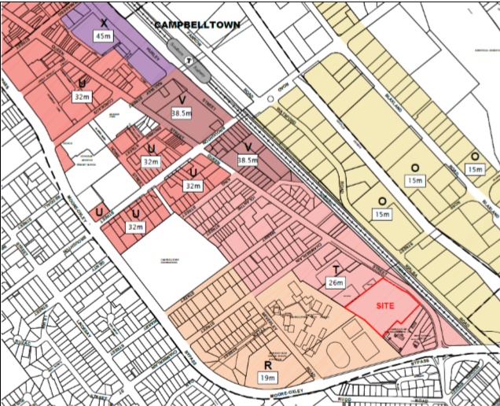

2.2 Building Envelopes - Primary, Side and Rear Setbacks

Under the provisions specified in Section 4.22(4), no development can proceed until subsequent development applications have been lodged and assessed for the final form of buildings on the site.

The concept plan has been designed to meet satisfactory compliance with the following SEPP 65 “building separation” requirements: -

Up to four (4) storeys (approximately 12 metres)

• 12m between habitable rooms/balconies;
• 9 m between habitable and non-habitable rooms;
• 6m between non-habitable rooms

Five (5) to eight (8) storeys (approximately 25 metres):

• 18m between habitable rooms/balconies
• 12m between habitable and non-habitable rooms
• 9m between non-habitable rooms

Nine (9) storeys and above (over 25 metres):

• 24m between habitable rooms/balconies
• 18m between habitable and non-habitable rooms
• 12m between non-habitable rooms

As illustrated below, the building separation between towers of 7 storeys meets satisfactory compliance with the required 18 metre minimum requirement for development between five (5) to (8) eight storeys in height.

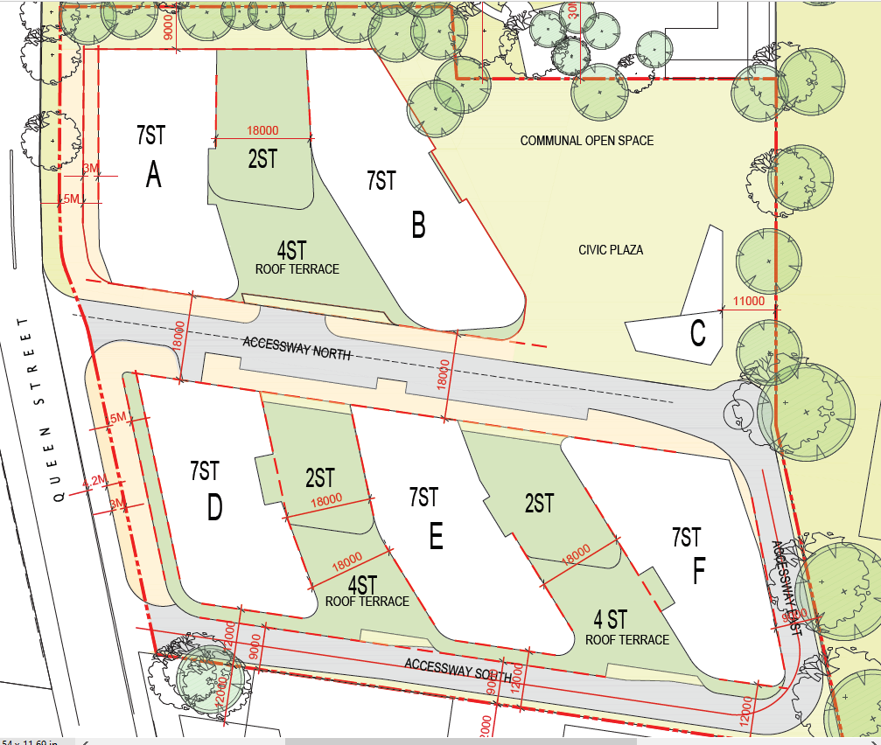

2.3 Private Open Space

As this development application seeks concept approval only, and not consent for physical works to construct the subject mixed-use proposal, a condition is recommended requiring that the locations, sizes and configurations of all the proposed open spaces areas are submitted as part of subsequent development applications in accordance with the specific requirements of SEPP 65 and the ADG.

Comment: Condition 1(f) of the Gateway Determination that was issued by the Department of Planning, Infrastructure and Environment (DPIE) on 17 January 2020, in support a Planning Proposal to increase the maximum building height on site, required that further options be investigated to increase the size of the proposed open space provision and that this amendment be introduced into the revised planning proposal.

The requirement resulted in the removal of former ‘Building C’, from the concept masterplan, and creation of approximately 4,000sqm of additional public open space in accordance with this Gateway condition. Further, the masterplan was also amended to incorporate additional open space on the accessible rooftop areas of each building tower and an increase in the ground floor setback to Queen Street, by a minimum of 5 metres, to support an activated public domain along this interface.

The below site plans detail the comparison between the scheme lodged with the original concept masterplan and the revised proposal which now includes the removal of ‘Building C’ and additional 4,000sqm of open space.

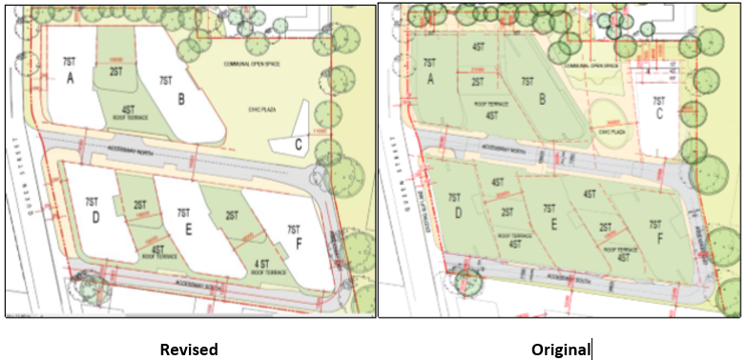

On 7 October 2020, the applicant provided the following clarification in response to the Panel request on 11 September 2020 about the future use of the proposed “Civic Plaza”: -

“The area between building B and the smaller building C is proposed to be publicly accessible. A detailed Landscape Plan was prepared and supports the application. However, given this is only a concept and further work is to be undertaken at design stage, the application does not seek consent for how this area will operate and function.

The primary purpose of the application is to seek consent for building footprints. This area is intended to be a community space that complements and integrates with Building C. While this may end up including a civic space, landscaping, grassed areas, and paving, the application does not seek specific consent for this, only that this area not include any building footprint.

Future development is intended to occur in accordance with the DCP extract below, with this space accessible to the community. To avoid confusion the term ‘Civic Plaza’ has been removed from the concept plans, and any future civic use will be part of a future process between the proponent and council.

Building C is approximately 450sq.m located within the open space area. There is a specific vision for this building to integrate and complement the open space. The Landscape Plan provides a vision and possible design outcomes for this. Envisaged future uses include a community facility, café and/or child care centre. However the application does not seek consent for use. We note that cafés, community facilities and child care centres are permissible in the B4 Mixed Use zone.”

The recommended conditions have been amended to refer to the amended plans.

2.4 Solar Access to Private Open Space (POS)

For areas greater than 25 dwellings per hectare, the SCDCP specifies that at least 70% of the proposed dwellings must receive a minimum of 3 hours sunlight, between 9am and 3pm at the winter solstice (21 June) into 50% of their POS areas. This is consistent with the submitted SEE which states that a minimum 75% of these residential apartments will be able to achieve this benchmark.

The development is capable of achieving this requirement. This will be assessed in detail for any subsequent development application seeking to construct residential development.

2.5 Solar Access to Living Areas

The submitted SEE indicates that 75% of all dwellings proposed within the five building towers will have the ability to receive a minimum of 3 hours of solar access into their living areas, which is consistent with the requirements of the ADG. This will be further assessed as part of subsequent applications.

2.6 Visual Privacy

The proposed concept plans appear to have been designed in a manner which will potentially ensure that each dwelling enjoys a reasonable amount of visual privacy. This will be further assessed as part of subsequent development applications.

2.7 Traffic, Transport and Car Parking

The applicant has submitted a ‘Traffic and Parking Impact Assessment’, prepared by McLaren Traffic Engineering and Road Safety Consultants.

The Report considered the following:

- The potential impacts of the future traffic generation, the appropriate access and circulation arrangements within the site and recommendations for future upgrades to the road network to accommodate growth.

- The potential traffic generation against both the SCDCP and RMS parking rates, and recommends that the RMS rates be adopted given the proximity of the site to an extensive network of public transport and the reduced impacts of future development.

- The impacts that future development will have on the surrounding road network, and make recommendations on the site access and circulation which will be incorporated and addressed beyond the concept DA stage. The report evaluates the geometries of three intersections that will be particularly affected and suggests appropriate upgrades to ensure acceptable intersection performance as the staged development is realised in the future. These intersections include Queen Street/Chamberlain Street, Campbelltown Road/Blaxland Road and Queen Street/Campbelltown Road.

The report recommends that more detailed design and testing of intersection upgrades be undertaken as the concept proposal becomes more refined and progresses to the next stage of development.

Councils’ engineers reviewed the applicant’s traffic assessment report and raised the following concerns:

- due to sight distance it would be unlikely to be possible to have a right turn entry to the site from Queen Street, and as such the entry would have to be’ left in’ only. To facilitate this design, the use of a central median would be required. This, however, may not be possible given the width of Queen Street corridor.

The revised concept has resulted in an increase in the ground floor setback to 5 metres, creating a ground floor setback of up to 9 metres from the existing kerb edge. This creates future flexibility for potential road widening, including more refined access arrangements and swept paths.

The planning proposal process will eventually inform the full access arrangements in conjunction with Council’s traffic engineers and RMS/Transport for NSW. As such, the proposed design may need to be revised and consideration should be given as to whether the submitted intersection design will facilitate all vehicle movements associated with this development application

2.8 Noise

Due to the location of the proposal opposite the rail line it is recommended that a condition be imposed requiring submission of a Noise Impact Assessment, prepared by a suitably qualified noise consultant, with subsequent development applications seeking approval to construct residential development which address the following:

- Intruding rail, road traffic and mechanical plant noise which has the potential to impact on the development.
- On-site rail and road traffic measurements which facilitate the preparation of a model to which accurately predicts the LAeq 15hr and LAeq 9hr noise levels across the entire site, as detailed on the Concept Master Plan. This modeling must also indicate that the noise levels being experienced on site are able to be easily attenuated by designing the external building façade treatments in a manner that facilitates achieving the specified internal noise criteria.
- The predicted rail, road traffic and mechanical plant noise levels at the façades of the proposed mixed-use buildings on site. Using these calculated façade exposure levels and the proposed constructions of the external walls and roof/ceilings of the dwellings, the required glazing and entry door performances must be calculated in accordance with the relevant Australian Standards.
- To achieve the internal limits the doors and windows need to be closed and mechanical ventilation or air-conditioning provided to the living areas and bedrooms to satisfy the ventilation requirements of the BCA.
- Mechanical plant and equipment noise emissions from the site have the potential to impact upon surrounding receivers in the future. To ensure that all plant and equipment is designed and installed to achieve compliance with Council requirements, recommended conditions of consent require written certification to be provided by a qualified acoustical consultant prior to the issue of an Occupation Certificate.
It is also noted that there is a potential for non-residential uses of the site to have noise impacts on residential uses through loading/unloading and through night time operations. It is recommended that a condition of consent be applied to require a report to be submitted with subsequent development application to detail measures that must be incorporated into the design of residential premises and any limitations that need to be applied to the operation of non-residential premises to ensure there are no unreasonable noise impacts and there is less opportunity for future land use conflict.

2.9 Geotechnical

A geotechnical validation report will be required to be prepared and submitted to Council to confirm the suitability of the site for the intended final land use. As the concept application does not seek operational consent to construct the subject proposal, any geotechnical issues that arise while preparing detailed drainage designs for the final development proposal will be addressed in a subsequent DA seeking operational consent.

2.10 Flooding

The following comments were provided by Council’s engineers:

- The site is affected by overland flow from the upstream lands in Campbelltown Performing Arts High School. Sufficient provision must be made to convey these flows through the site. This can be achieved in a number of ways (pipes, swales, etc.) and Infrastructure is happy to assist with any discussions in this regard.

- The site is also affected by flooding in Queen Street and control levels will be required. These can be determined as part of the submitted concept application.

- The existing development on the ‘Brands on Sale’ site contains provision for both overland flow (via two swales through the ground floor level of the carpark) and flooding in Queen Street (the development floor levels have been raised to the required levels).

- The proposal appears to provide opportunity to accommodate the above requirements. There appear to be open areas which could be used to convey overland flow. Floor level controls can be set to address flooding in Queen Street. Care would be required to ensure the underground carpark openings were located such that flood waters could not enter.

These matters are able to be addressed as part of subsequent development applications. It is recommended that a condition be imposed to alert the applicant to future development of the site to this requirement.

2.11 Stormwater and Water Quality Control

A stormwater concept design, prepared by SGCE, demonstrated that the subsoil pump out system and basement drainage designs will be supported by appropriate stormwater drainage measures. These are able to be detailed in subsequent development applications.

3. Public Participation

The application was publicly exhibited and notified to nearby residents and property owners. No submissions were received.

4. Conclusion

Having regard to the matters for consideration under Section 4.15 and Section 4.22 (Concept Plan Applications) of the Environmental Planning and Assessment Act 1979 and the issues raised above, it is considered that the application is consistent with the relevant planning legislation.

This concept application has been determined to meet satisfactory compliance with all of the relevant State Environmental Planning Policies, Campbelltown Local Environmental Plan 2015 and the Campbelltown (Sustainable City) Development Control Plan 2015.

Accordingly, the application is recommended for approval, subject to conditions.

Officer's Recommendation

That Development Application 308/2019/DA-CP for a concept masterplan for Lot X DP 409704, Lot 15 DP 14782, Lot 1 DP 1154928, Nos. 22 – 32 Queen Street, CAMPBELLTOWN, be approved subject to the attached conditions.

